**Assessment exercise**

**CWB110**

Extract ***assessment.zip*** on your workstation.

**Included Files –**

* **assessment_txt.html** – this file contains all page content. You will rename it to assessment.html.
* **assessment_txt.css** – the external .css file you will rename to assessment.css. ***You will need to link to this file from your assessment.html file***.
* **images** – this folder contains the images you will need for the project – **strawberries.jpg**, **strawberry-tiny.png, and** **header.jpg**.

**Get set up -**

* Review **assessment.html** in your text editor. Note that the page structure has been outlined for you. Note that there is a <div> tag uniquely identified with an id attribute (“container”) along with other HTML5 structural elements.
* Format the page exactly as indicated in the screen shots below by adding to the **assesment.css**, the external style sheet as explained in the instructions. You will also need to add a few lines to assessment.html as explained in the instructions.

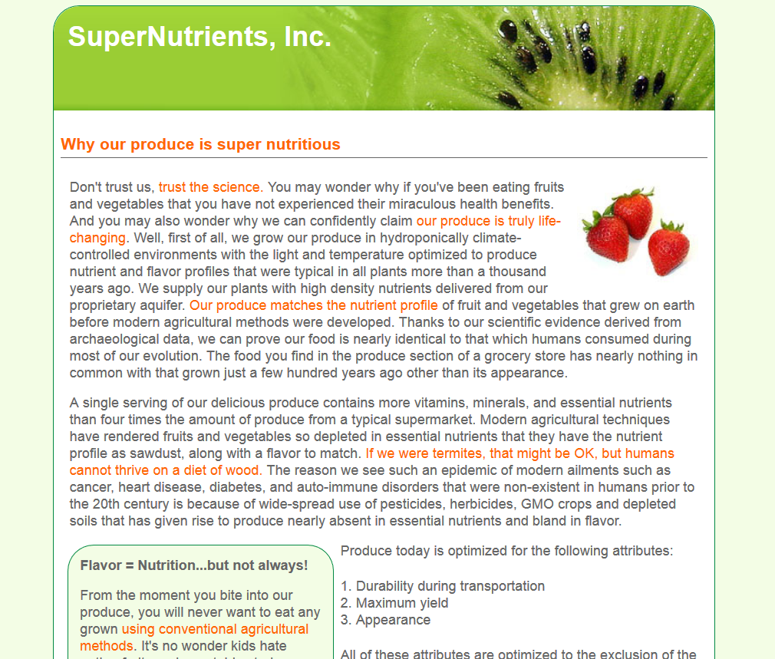

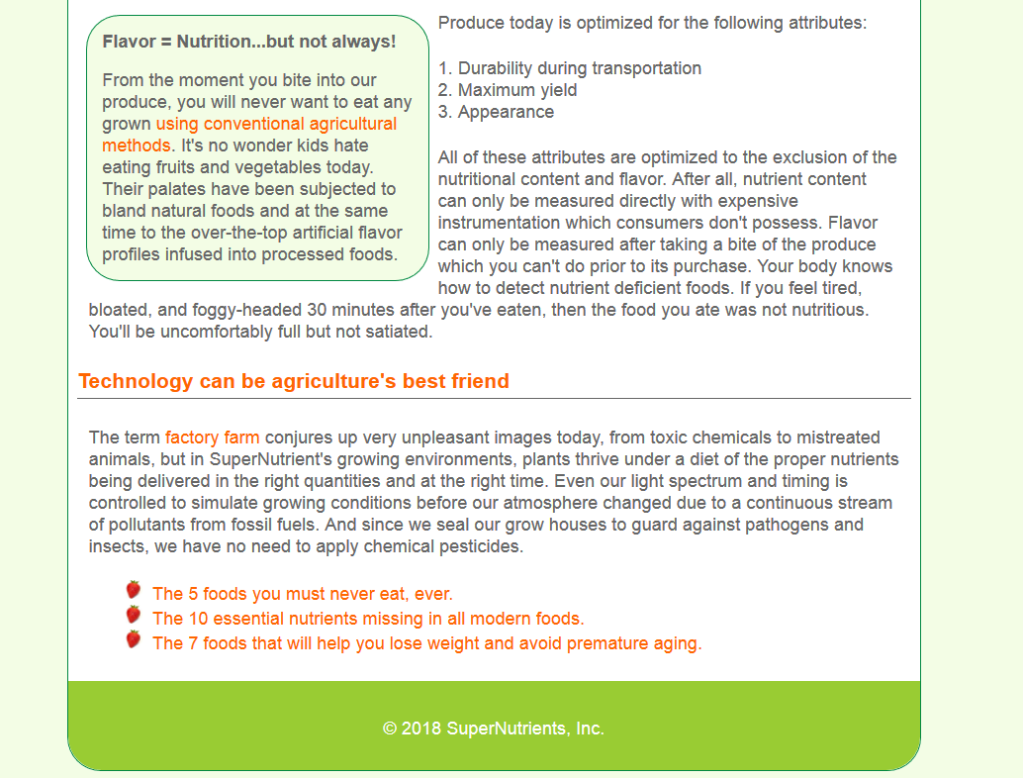

**Step by step instructions:**

1. Open the assessment_txt.html file and include your name and the date in the comment section. Save it with the name **assessment.html**. Open the assessment_txt.css file and put your name and date in the comment section and save it with the name **assessment.css**.
2. Add a link in the head of the assessment.html file to the assessment.css file.
3. Add a title tag in the assessment.html file so that the text 'SuperNutrients, Inc' appears in the tab when the file is opened in a browser.
4. In the assessment.css file, format the body so that it has a font stack of Arial, Helvetica, sans-serif. Set the body background color to #f3fde5. Set the body font color to #666.
5. Format the div with the ID "container" to have a width of 760px, no margin on the top or bottom and centered left and right. Set the border to be 1px wide solid line with a color of #018843. Set the background color of the container to white and its border radius to 30px.
6. Format the header element to have a background image set to the header.jpg image. Its top left and top right border radius should be set to the same as the container's radius. Its height should be set to be the same as the height as the header.jpg file.
7. Add an img tag to the first paragraph in the assessment.html file to load the strawberries.jpg image and float the image to the right so that the paragraph wraps around it.
8. The section element should have .5em of padding all around.
9. Set the h1 tag in the header to have a color of white and a top padding of .5em and a left padding of .5em.
10. Set all h3 tags to have a color of #f60, and a bottom padding of 4px and a bottom border of 1px solid with a color of #666.
11. Set all hyperlinks to have a color of #f60 and text-decoration of none. When hovering over the links, set the text decoration to be underlined.
12. Set the aside element to have a width of 40%, float it to the left, set its background color to #f6fcec (same as the body), and a border to be 1px wide solid and a color of #018843. Set all padding to .2em, top margin and right margin to 8px and the bottom and left margin to 0. Set the border radius to 30px.
13. Set the footer's background color to #9c3, its height to 48px, the font color to white, align the text inside it to the center and add top padding of 32px. Give the bottom left and right radii value to match the radii on its parent div. Add the copyright symbol in the footer text in the assessment.html file.
14. There are two lists, one ordered and one unordered. Both of them should have the list style position set to inside. The unordered list should have its bullets set to the images of the strawberry-tiny.png.
15. When you are satisfied that the page looks like the image, upload your files to your cislinux account in a folder called assessment and update your index.html file. Then place an itsup.txt in the Assignments area so I will be able to assess it.

***Note: Be sure your page displays as shown in the Firefox browser. You can check it in other browsers, but be sure it displays correctly in Firefox as that is the browser that will be used to grade your project.***